1. Went to Incomplete Tab and picked up this Policy #

2. It is only when I click Save Button then the TP Assignment & OD Assignment Fields appear on the Accident Tab and when I go to other tabs and back to the Accident Tab, these two fields disappear

On new claim registration menu

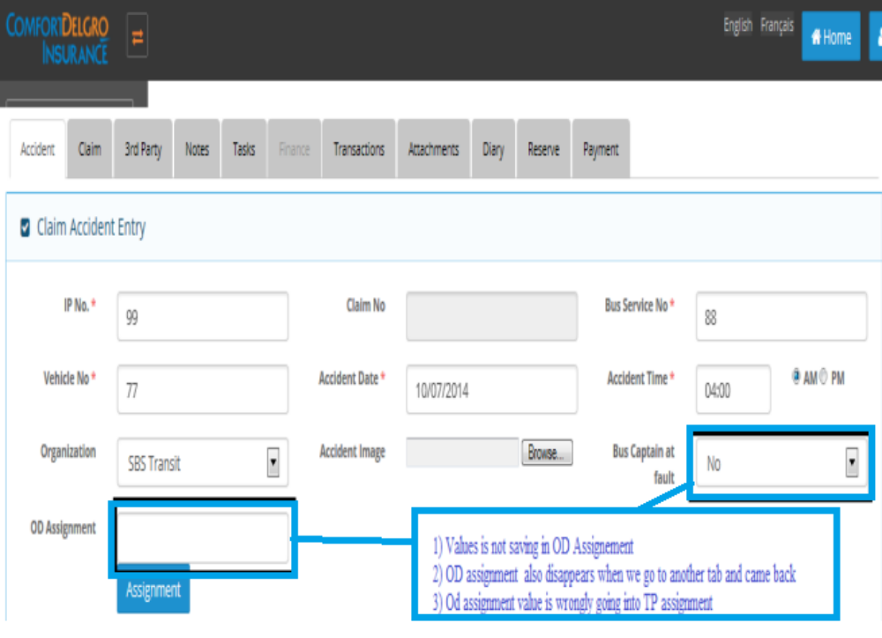

On incomplete claim registration menu

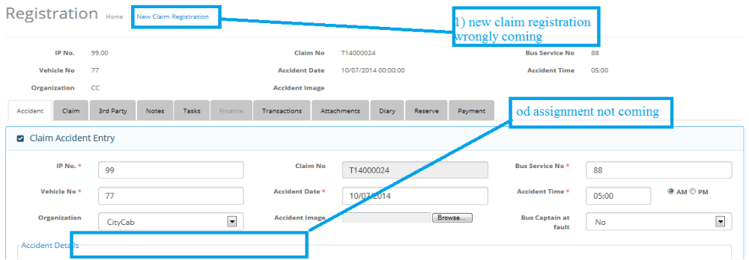

3. On Claim Tab – if I keep clicking on Save without any inputs – a new Claim No will be generated and the previous claim # T14000013 disappears from the listings

* Resolved

4. On 3rd Party Tab – created and save a new entry and previous entries on other tabs disappeared and system also shows a message below “unable to save changes”

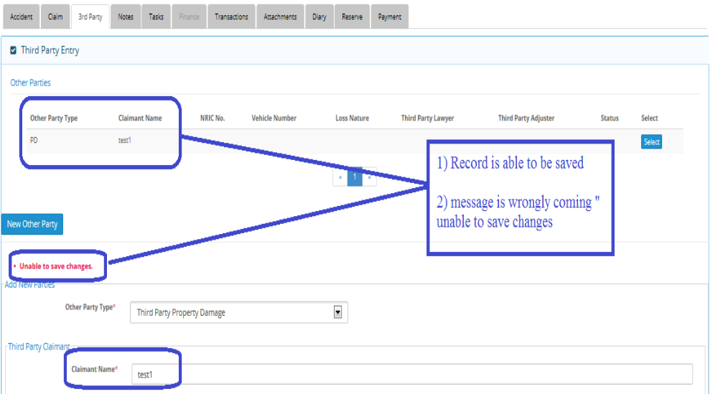

I have added two records test1 and test2 but test1 Is getting replaced with test2 and in grid only one record is displaying.

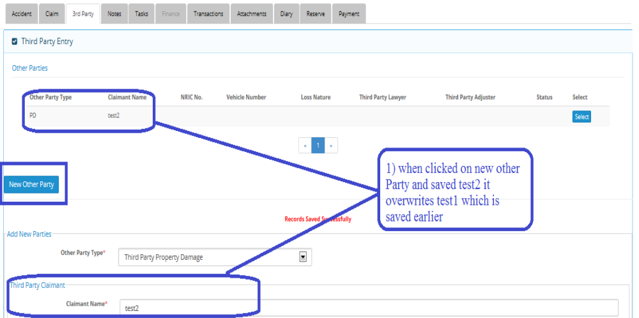

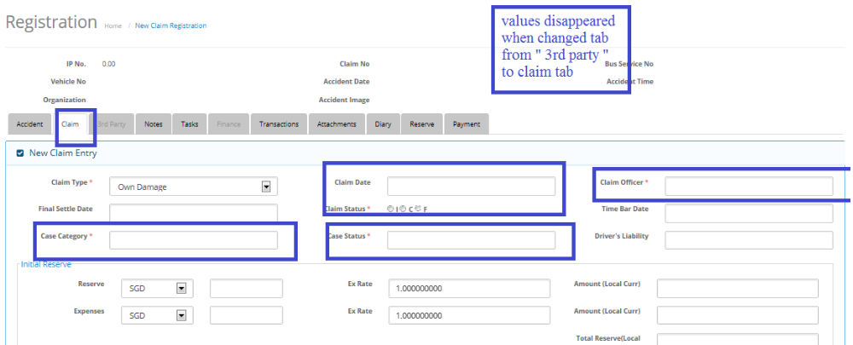

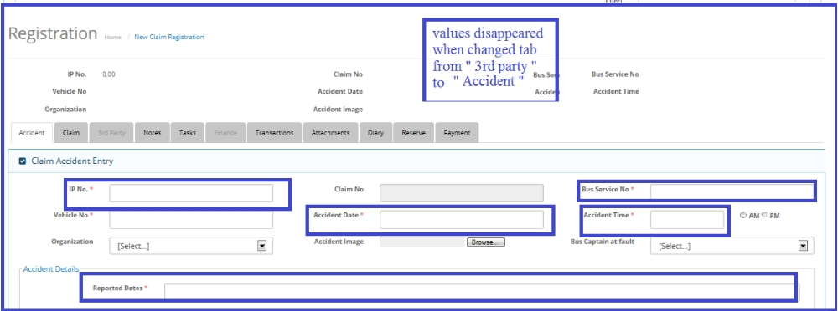

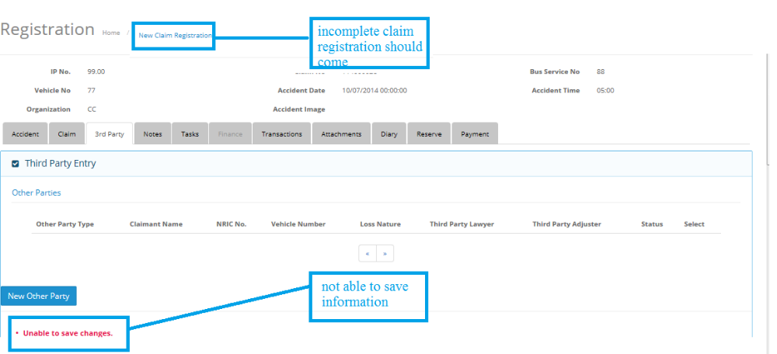

5. On 3rd Party Tab – created entries disappears after revisiting the same claim no.

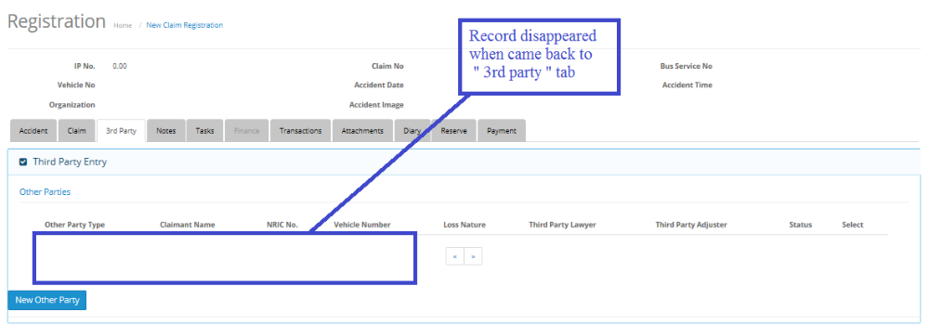

6. On Notes Tab – unable to save any Notes and previous entries disappears

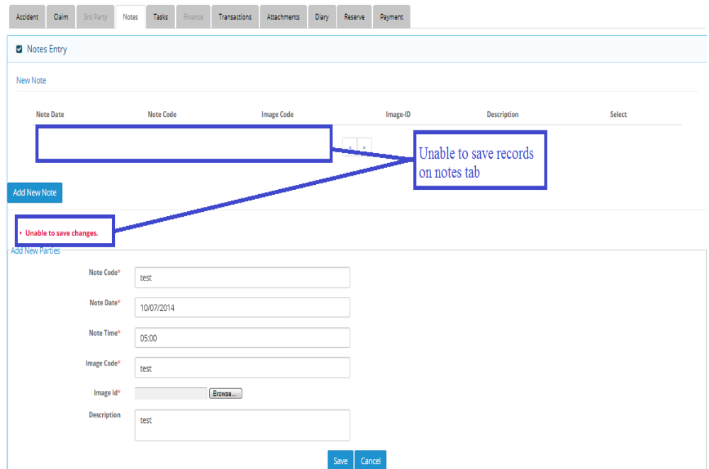

7. On Transaction Tab – unable to save any Transaction and previous entries disappears

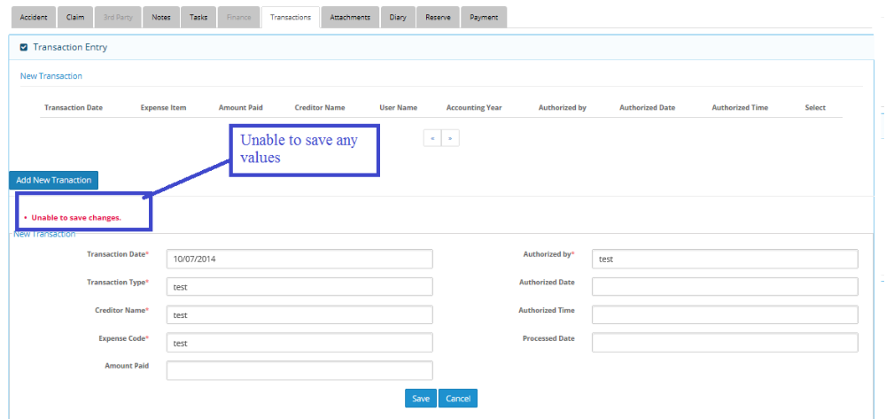

8. On Diary Tab – system says that entry is saved but unable to retrieve anything from Diary Tab

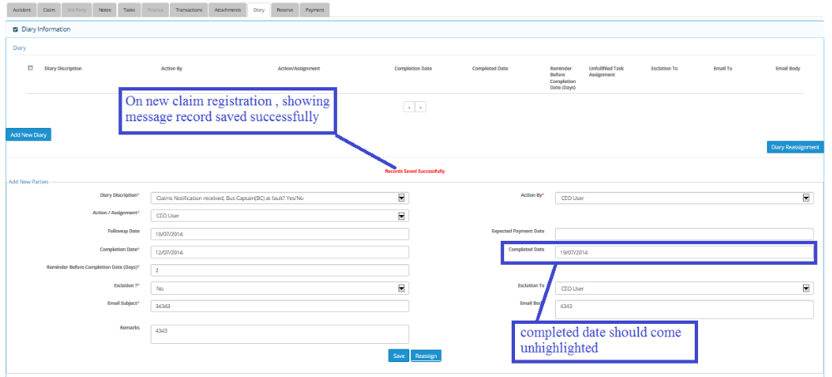

9. On Reserve Tab – still not sure how to add a Claimant

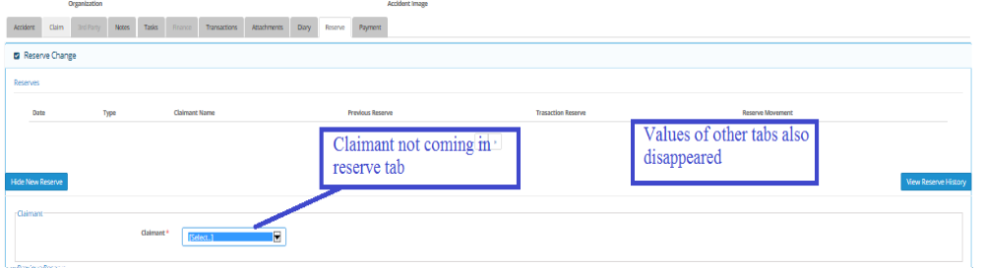

10. On Payment Tab – click on it from Reserve Tab and previous entries disappear and unable to create because there’s no Claimant to select

